**Assignment 4**

**1. Loan Amortization Calculator**

Implement a system to calculate and display the monthly payments for a mortgage loan. The system should:

1. Accept the principal amount (loan amount), annual interest rate, and loan term (in years) from the user.
2. Calculate the monthly payment using the standard mortgage formula:
   * **Monthly Payment Calculation:**
     + monthlyPayment = principal * (monthlyInterestRate * (1 + monthlyInterestRate)^(numberOfMonths)) / ((1 + monthlyInterestRate)^(numberOfMonths) - 1)
     + Where monthlyInterestRate = annualInterestRate / 12 / 100 and numberOfMonths = loanTerm * 12
     + Note: Here ^ means power and to find it you can use Math.pow( ) method
3. Display the monthly payment and the total amount paid over the life of the loan, in Indian Rupees (₹).

Code :-

**package** calculator;

**import** java.util.Scanner;

**public** **class** Program1 {

**private** **double** principal;

**private** **double** annualInterestRate;

**private** **int** loanTerm;

//get and set

**public** **double** getPrincipal() {

**return** principal;

}

**public** **void** setPrincipal(**double** principal) {

**this**.principal = principal;

}

// Getter and Setter for annualInterestRate

**public** **double** getAnnualInterestRate() {

**return** annualInterestRate;

}

**public** **void** setAnnualInterestRate(**double** annualInterestRate) {

**this**.annualInterestRate = annualInterestRate;

}

// Getter and Setter for loanTerm

**public** **int** getLoanTerm() {

**return** loanTerm;

}

**public** **void** setLoanTerm(**int** loanTerm) {

**this**.loanTerm = loanTerm;

}

// calculate the monthly payment

**public** **double** calculateMonthlyPayment() {

**double** monthlyInterestRate = annualInterestRate / 12 / 100;

**int** numberOfMonths = loanTerm * 12;

**return** principal * (monthlyInterestRate * Math.*pow*(1 + monthlyInterestRate, numberOfMonths))/ (Math.*pow*(1 + monthlyInterestRate, numberOfMonths) - 1);

}

// calculate the total amount paid

**public** **double** calculateTotalAmountPaid() {

**return** calculateMonthlyPayment() * loanTerm * 12;

}

**public** **static** **void** main(String[] args) {

Program1 calculator = **new** Program1();

// Create a Scanner

Scanner scanner = **new** Scanner(System.***in***);

System.***out***.print("Enter the loan amount in INR: ");

calculator.setPrincipal(scanner.nextDouble());

System.***out***.print("Enter the annual interest rate: ");

calculator.setAnnualInterestRate(scanner.nextDouble());

System.***out***.print("Enter the loan term : ");

calculator.setLoanTerm(scanner.nextInt());

scanner.close();

// Calculate monthly payment and total amount paid

**double** monthlyPayment = calculator.calculateMonthlyPayment();

**double** totalAmountPaid = calculator.calculateTotalAmountPaid();

// Display the results

System.***out***.printf("Monthly Payment: ₹%.2f%n", monthlyPayment);

System.***out***.printf("Total Amount Paid Over the Life of the Loan: ₹%.2f%n", totalAmountPaid);

}

}

Output –

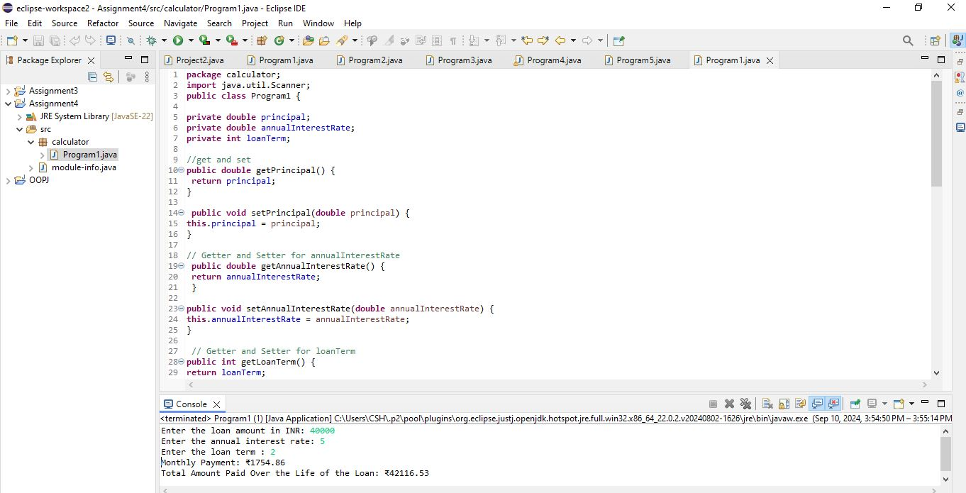

**2. Compound Interest Calculator for Investment**

Develop a system to compute the future value of an investment with compound interest. The system should:

1. Accept the initial investment amount, annual interest rate, number of times the interest is compounded per year, and investment duration (in years) from the user.
2. Calculate the future value of the investment using the formula:
   * **Future Value Calculation:**
     + futureValue = principal * (1 + annualInterestRate / numberOfCompounds)^(numberOfCompounds * years)
   * **Total Interest Earned:** totalInterest = futureValue - principal
3. Display the future value and the total interest earned, in Indian Rupees (₹).

Code :-

**package** calculator;

**import** java.util.Scanner;

**public** **class** Program2 {

**private** **double** principal;

**private** **double** annualInterestRate;

**private** **int** numberOfCompounds;

**private** **int** years;

// Get and Set

**public** **double** getPrincipal() {

**return** principal;

}

**public** **void** setPrincipal(**double** principal) {

**this**.principal = principal;

}

// Getter and Setter for annualInterestRate

**public** **double** getAnnualInterestRate() {

**return** annualInterestRate;

}

**public** **void** setAnnualInterestRate(**double** annualInterestRate) {

**this**.annualInterestRate = annualInterestRate;

}

// Getter and Setter for numberOfCompounds

**public** **int** getNumberOfCompounds() {

**return** numberOfCompounds;

}

**public** **void** setNumberOfCompounds(**int** numberOfCompounds) {

**this**.numberOfCompounds = numberOfCompounds;

}

// Getter and Setter for years

**public** **int** getYears() {

**return** years;

}

**public** **void** setYears(**int** years) {

**this**.years = years;

}

//calculate the future value

**public** **double** calculateFutureValue() {

**double** ratePerPeriod = annualInterestRate / numberOfCompounds / 100;

**int** totalPeriods = numberOfCompounds * years;

**return** principal * Math.*pow*(1 + ratePerPeriod, totalPeriods);

}

// Method to calculate the total interest earned

**public** **double** calculateTotalInterest() {

**return** calculateFutureValue() - principal;

}

**public** **static** **void** main(String[] args) {

Program2 calculator = **new** Program2();

// Create a Scanner

Scanner scanner = **new** Scanner(System.***in***);

System.***out***.print("Enter the initial investment amount: ");

calculator.setPrincipal(scanner.nextDouble());

System.***out***.print("Enter the annual interest rate : ");

calculator.setAnnualInterestRate(scanner.nextDouble());

System.***out***.print("Enter number of times the interest is compounded per year: ");

calculator.setNumberOfCompounds(scanner.nextInt());

System.***out***.print("Enter the investment duration: ");

calculator.setYears(scanner.nextInt());

scanner.close();

// Calculate future value and total interest earned

**double** futureValue = calculator.calculateFutureValue();

**double** totalInterest = calculator.calculateTotalInterest();

// Display the results

System.***out***.printf("Future Value: ₹%.2f%n", futureValue);

System.***out***.printf("Total Interest Earned: ₹%.2f%n", totalInterest);

}

}

Output –

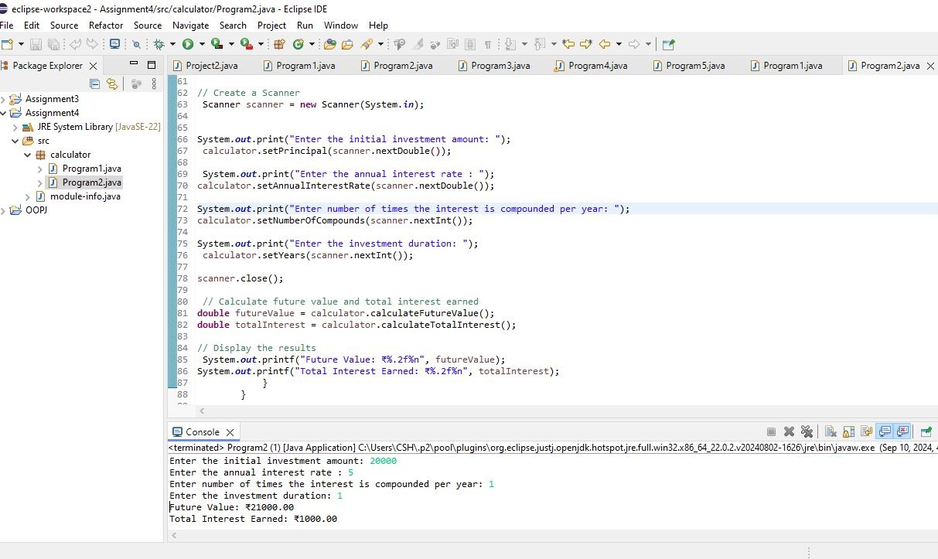

**3. BMI (Body Mass Index) Tracker**

Create a system to calculate and classify Body Mass Index (BMI). The system should:

1. Accept weight (in kilograms) and height (in meters) from the user.
2. Calculate the BMI using the formula:
   * **BMI Calculation:** BMI = weight / (height * height)
3. Classify the BMI into one of the following categories:
   * Underweight: BMI < 18.5
   * Normal weight: 18.5 ≤ BMI < 24.9
   * Overweight: 25 ≤ BMI < 29.9
   * Obese: BMI ≥ 30
4. Display the BMI value and its classification.

Code:-

**package** calculator;

**import** java.util.Scanner;

**public** **class** Program3 {

**private** **double** weight;

**private** **double** height;

// Get and Set

**public** **double** getWeight() {

**return** weight;

}

**public** **void** setWeight(**double** weight) {

**this**.weight = weight;

}

// Getter and Setter for height

**public** **double** getHeight() {

**return** height;

}

**public** **void** setHeight(**double** height) {

**this**.height = height;

}

// Method calculate BMI

**public** **double** calculateBMI() {

**return** weight / (height * height);

}

// Method classify BMI

**public** String classifyBMI(**double** bmi) {

**if** (bmi < 18.5) {

**return** "Underweight";

}

**else** **if** (bmi >= 18.5 && bmi < 24.9) {

**return** "Normal weight";

}

**else** **if** (bmi >= 25 && bmi < 29.9) {

**return** "Overweight";

}

**else** {

**return** "Obese";

}

}

**public** **static** **void** main(String[] args) {

Program3 bmiTracker = **new** Program3();

// Create a Scanner object for user input

Scanner scanner = **new** Scanner(System.***in***);

// Prompt the user to enter weight and height

System.***out***.print("Enter your weight: ");

bmiTracker.setWeight(scanner.nextDouble());

System.***out***.print("Enter your height: ");

bmiTracker.setHeight(scanner.nextDouble());

scanner.close();

// Calculate BMI

**double** bmi = bmiTracker.calculateBMI();

// Classify BMI

String classification = bmiTracker.classifyBMI(bmi);

// Display the results

System.***out***.printf("Your BMI: %.2f%n", bmi);

System.***out***.println("BMI Classification: " + classification);

}

}

Output –

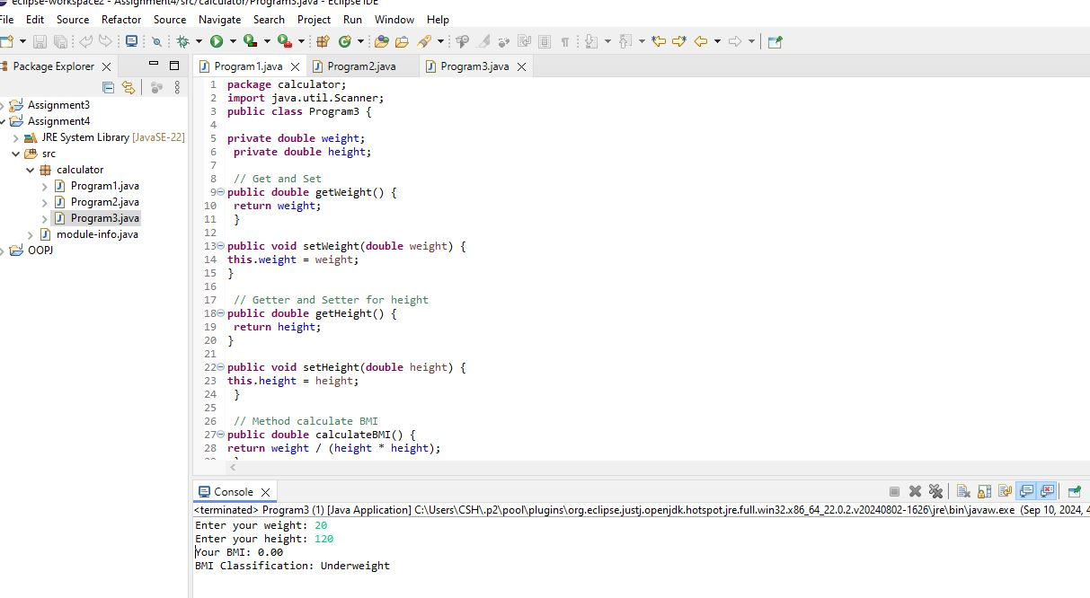

**4. Discount Calculation for Retail Sales**

Design a system to calculate the final price of an item after applying a discount. The system should:

1. Accept the original price of an item and the discount percentage from the user.
2. Calculate the discount amount and the final price using the following formulas:
   * **Discount Amount Calculation:** discountAmount = originalPrice * (discountRate / 100)
   * **Final Price Calculation:** finalPrice = originalPrice - discountAmount
3. Display the discount amount and the final price of the item, in Indian Rupees (₹).

Code –

**package** calculator;

**import** java.util.Scanner;

**public** **class** Program4 {

**private** **double** originalPrice;

**private** **double** discountRate;

// Get and Set

**public** **double** getOriginalPrice() {

**return** originalPrice;

}

**public** **void** setOriginalPrice(**double** originalPrice) {

**this**.originalPrice = originalPrice;

}

// Getter and Setter for discountRate

**public** **double** getDiscountRate() {

**return** discountRate;

}

**public** **void** setDiscountRate(**double** discountRate) {

**this**.discountRate = discountRate;

}

// calculate the discount amount

**public** **double** calculateDiscountAmount() {

**return** originalPrice * (discountRate / 100);

}

// calculate the final price

**public** **double** calculateFinalPrice() {

**return** originalPrice - calculateDiscountAmount();

}

**public** **static** **void** main(String[] args) {

Program4 calculator = **new** Program4();

// Create a Scanner

Scanner scanner = **new** Scanner(System.***in***);

// enter original price and discount rate

System.***out***.print("Enter the original price of the item : ");

calculator.setOriginalPrice(scanner.nextDouble());

System.***out***.print("Enter the discount rate: ");

calculator.setDiscountRate(scanner.nextDouble());

scanner.close();

// Calculate discount amount and final price

**double** discountAmount = calculator.calculateDiscountAmount();

**double** finalPrice = calculator.calculateFinalPrice();

// Display the results

System.***out***.printf("Discount Amount: ₹%.2f%n", discountAmount);

System.***out***.printf("Final Price: ₹%.2f%n", finalPrice);

}

}

Output –

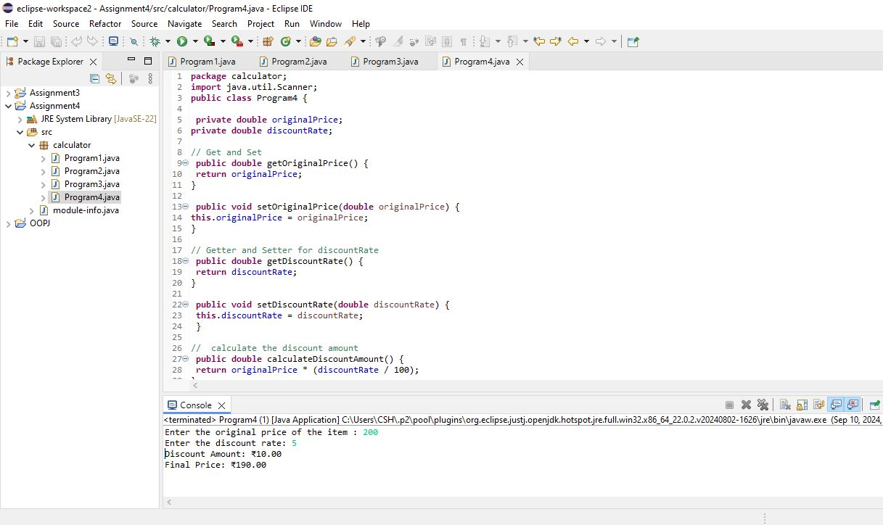

**5. Toll Booth Revenue Management**

Develop a system to simulate a toll booth for collecting revenue. The system should:

1. Allow the user to set toll rates for different vehicle types: Car, Truck, and Motorcycle.
2. Accept the number of vehicles of each type passing through the toll booth.
3. Calculate the total revenue based on the toll rates and number of vehicles.
4. Display the total number of vehicles and the total revenue collected, in Indian Rupees (₹).

* **Toll Rate Examples:**
  + Car: ₹50.00
  + Truck: ₹100.00
  + Motorcycle: ₹30.00

Code :-

**package** calculator;

**import** java.util.Scanner;

**public** **class** Program5 {

**private** **double** carTollRate;

**private** **double** truckTollRate;

**private** **double** motorcycleTollRate;

**private** **int** carCount;

**private** **int** truckCount;

**private** **int** motorcycleCount;

// Get and Set

**public** **double** getCarTollRate() {

**return** carTollRate;

}

**public** **void** setCarTollRate(**double** carTollRate) {

**this**.carTollRate = carTollRate;

}

// Getter and Setter for truckTollRate

**public** **double** getTruckTollRate() {

**return** truckTollRate;

}

**public** **void** setTruckTollRate(**double** truckTollRate) {

**this**.truckTollRate = truckTollRate;

}

// Getter and Setter for motorcycleTollRate

**public** **double** getMotorcycleTollRate() {

**return** motorcycleTollRate;

}

**public** **void** setMotorcycleTollRate(**double** motorcycleTollRate) {

**this**.motorcycleTollRate = motorcycleTollRate;

}

// Getter and Setter for carCount

**public** **int** getCarCount() {

**return** carCount;

}

**public** **void** setCarCount(**int** carCount) {

**this**.carCount = carCount;

}

// Getter and Setter for truckCount

**public** **int** getTruckCount() {

**return** truckCount;

}

**public** **void** setTruckCount(**int** truckCount) {

**this**.truckCount = truckCount;

}

// Getter and Setter for motorcycleCount

**public** **int** getMotorcycleCount() {

**return** motorcycleCount;

}

**public** **void** setMotorcycleCount(**int** motorcycleCount) {

**this**.motorcycleCount = motorcycleCount;

}

// Method to calculate total revenue

**public** **double** calculateTotalRevenue() {

**return** (carCount * carTollRate) + (truckCount * truckTollRate) + (motorcycleCount * motorcycleTollRate);

}

// Method to calculate total number of vehicles

**public** **int** calculateTotalVehicles() {

**return** carCount + truckCount + motorcycleCount;

}

**public** **static** **void** main(String[] args) {

// Create an instance of TollBooth

Program5 tollBooth = **new** Program5();

// Create a Scanner

Scanner scanner = **new** Scanner(System.***in***);

// Set toll rates for vehicles

System.***out***.print("Enter toll rate for Car (in INR): ");

tollBooth.setCarTollRate(scanner.nextDouble());

System.***out***.print("Enter toll rate for Truck (in INR): ");

tollBooth.setTruckTollRate(scanner.nextDouble());

System.***out***.print("Enter toll rate for Motorcycle (in INR): ");

tollBooth.setMotorcycleTollRate(scanner.nextDouble());

// Accept the number of vehicles of each type

System.***out***.print("Enter the number of Cars: ");

tollBooth.setCarCount(scanner.nextInt());

System.***out***.print("Enter the number of Trucks: ");

tollBooth.setTruckCount(scanner.nextInt());

System.***out***.print("Enter the number of Motorcycles: ");

tollBooth.setMotorcycleCount(scanner.nextInt());

scanner.close();

// Calculate total revenue and total number of vehicles

**double** totalRevenue = tollBooth.calculateTotalRevenue();

**int** totalVehicles = tollBooth.calculateTotalVehicles();

// Display the total number of vehicles and total revenue

System.***out***.printf("Total Number of Vehicles: %d%n", totalVehicles);

System.***out***.printf("Total Revenue Collected: ₹%.2f%n", totalRevenue);

}

}

Output –

